

HIGH-PRESSURE WASHER  
FNHP2050CP

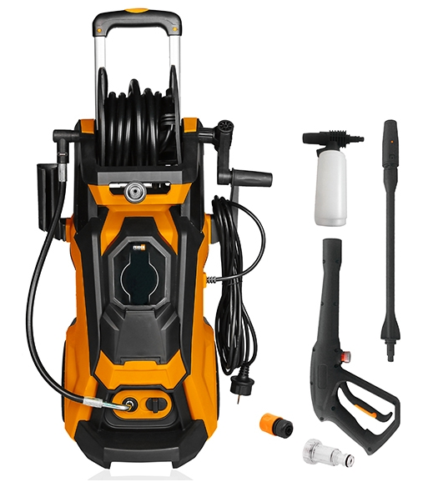

CAUTION: READ THE INSTRUCTIONS BEFORE USING THE MACHINE

BUILDER SAS

32, rue Aristide Bergès -ZI 31270 Cugnaux –France

Made in PRC - 2020 

**CONTENTS**

1. **SAFETY INSTRUCTIONS 3**
2. **PRODUCT VIEW 12**
3. **ASSEMBLY 14**
4. **USE 16**
5. **MAINTENANCE AND STORAGE 17**
6. **TROUBLESHOOTING 18**
7. **DISPOSAL 18**
8. **WARRANTY 19**
9. **DECLARATION OF CONFORMITY 20**
10. **SAFETY INSTRUCTIONS**

* Use this unit as described in this manual. Any mishandling and any use contrary to instructions for use shall in no case be the responsibility of the manufacturer.
* Failure to observe the safety and operating instructions may result in a risk of electric shock, fire and / or personal injury.
* If you are giving this unit to another person, please also provide this manual.
* Do not use attachments other than those recommended by the manufacturer; they can damage the unit and / or cause injury.
* Machines shall not be used by children. Children should be supervised to ensure that they do not play with the appliance.
* This machine can be used by people with reduced physical, sensory or mental capabilities or lack of experience and knowledge if they have been given supervision or instruction concerning use of the machine in a safe way and understand the hazards involved.
* Children shall not play with the appliance.
* If the supply cord is damaged, it must be replaced by the manufacturer, its service agent or similarly qualified persons in order to avoid a hazard.
* Before any connection, check:
* The appliance, power cable and accessories are not damaged. In this case, do not use the appliance and take it to your dealer for inspection and repair.
* The voltage indicated on the rating plate of the appliance corresponds to that of your electrical installation.
* Do not disassemble the device yourself. Any disassembly, repair or inspection should be carried out exclusively by a qualified person.
* Do not touch the plug with wet hands. Do not allow the plug to fall into the water.
* Do not walk on the power cord, do not exert excessive pressure, or pull on the cord to avoid damage.
* WARNING: This machine has been designed for use with a cleaning agent supplied or recommended by the manufacturer. Use of other cleaning or chemical agents may affect the safety of the machine.
* WARNING: High pressure jets can be dangerous if subject to misuse. The jet must not be directed at persons, live electrical equipment or the machine itself.
* WARNING: Do not use the machine within range of persons unless they wear protective clothing
* WARNING: Do not direct the jet against yourself or others in order to clean clothes or footwear.
* WARNING: Risk of explosion. Do not spray flammable liquids.
* WARNING: High pressure cleaners shall not be used by children or untrained personnel.
* WARNING: The machine shall be disconnected from its power source during cleaning or maintenance and when replacing parts or converting the machine to another function.
* WARNING: High pressure hoses, fittings and couplings are important for the safety of the machine. Use only hoses, fittings and couplings recommended by the manufacturer.
* WARNING: To ensure the safety of the machine, use only the original manufacturer's parts or approved by the manufacturer.
* WARNING: Water that has flowed through backflow preventers is considered to be non-potable.
* WARNING: The machine must be disconnected from the power supply during cleaning or maintenance and when replacing parts or converting the machine to other functions by removing the power source plug.
* WARNING: Do not use the machine if a supply cord or important parts of the machine are damaged, e.g. safety devices, high pressure hoses, trigger gun.
* WARNING: If an extension cord is used, the plug and cable must be watertight.
* WARNING: Inadequate extension cords can be dangerous. If an extension cord is used, it shall be suitable for outdoor use, and the connection has to be kept dry and off the ground. It is recommended that this is accomplished by means of a cord reel which keeps the socket at least 60 mm above the ground.
* WARNING: Make sure there are no exhaust emissions near the air intakes.
* Children, animals and persons not participating in the use of the machine must remain at a minimum distance of 10 meters from the sprayer.
* The high pressure hose must remain connected to the compressor as long as the system is under pressure.
* Do not use corrosive or flammable liquids in the machine.
* The appliance must be connected to a water supply using a new set of hoses; the old pipe set must not be reused.
* Make sure that there are no exhaust emissions near the air inlets.
* When using the machine, wear protective equipment including safety goggles, safety shoes, safety gloves, safety helmet with visor and double-insulated hearing protection.
* In order to move the unit easily, bend the lance.
* Make sure the unit is turned off and unplugged before transporting the unit.
* The connection to the power supply must be made by a qualified electrician in accordance with IEC60364-1. It is recommended that the power supply of this machine includes a residual current device that interrupts power if the earth leakage exceeds 30 mA for 30 ms or a device that will homologate the earth circuit.
* Before assembling, dismantling, repairing, transporting, servicing and storing, please check if the appliance is disconnected from the power supply. •
* Handle the unit with care, do not drop it.
* Do not use the machine in extreme weather conditions, when it is very cold. Do not use the machine with ice water.
* Use the tool in a stable and plane location.
* The inlet hose can be connected to the water mains with a maximum pressure of 10 bars.
* If the device is to be connected to a drinking water network (exclusively in Europe), an appropriate network valve must be installed (type BA, standard EN1717). Water that will be passed through the valve is considered non-potable.
* WARNING: In order to avoid any danger due to the accidental reset of the thermal circuit breaker, this device must not be powered via an external switch, such as a timer, or be connected to a circuit which is regularly connected switched on and off by the electricity supplier.
* The appliance must not be connected to potable water supply.
* CAUTION: In order to avoid danger due to untimely resetting of the thermal cut-out, this device must not be powered by an external switch, such as a timer, or connected to a circuit that is regularly switched on energized and de-energized by the electricity supplier.
* When transporting the machine, take note of its weight. Do not overestimate your efforts and get help if necessary.
* The machine must be transported from one point to another and disconnected. Always use the handle to push the machine.
* Use the handle to lift the machine.
* Improper transport of the machine may result accidents and injuries.
* Do not use the tool where dangerous situations or accidents may occur. Do not use it indoor, in places where are exhausted gases, etc.
* In case of accidents or breakdowns, stop to use the tool, switch off it and unplug it. Check the conditions of the tool and bring it to a service agent for inspection and reparation if necessary.
* When opening the trigger gun, pay attention to the kickback force. The power of the gun can cause a kickback and can produce a loss of control of the gun and create accidents and injuries. Hold the gun firmly, and with both hands if possible.
* WARNING Always switch off the mains disconnecting switch when leaving the machine unattended.
* To avoid dangerous situations in the event of an accident (for example, contact with or spill of detergents) or equipment failure (such as a puncture or a component failure), please stop using the machine immediately. Check the problem. Have the machine inspected by a qualified technician. In the event of an overflow, move the machine away and clean the overflow.
* WARNING Always turn off the main switch when leaving the machine unattended.
* During use, transport, assembly, disassembly, in case of failure, during foreseeable tests or breakdowns, the tool must always remain upright.
* Do not use the tool in dangerous situations or when an accident has occurred. Do not use indoors, in places where gases can be emitted, etc.

**Residual risks**

Even if you are operating this product in accordance with all the safety requirements, potential risks of injury and damage remain. The following dangers can arise in connection with the structure and design of this product:

* Health defects resulting from vibration emission if the product is being used over long periods of time or not adequately managed and properly maintained
* Danger of injury and property damage caused by flying objects.
* Injuries and damage to property due to broken accessories or the sudden impact of hidden objects during use.

**Intended use**

Your PRESSURE CLEANER can perform a myriad of tasks in the house and in the garden. It effectively cleans a wide variety of surfaces.

Your PRESSURE CLEANER is designed to operate from a cold water supply.

It operates efficiently with water whose temperature is between 5 and 60 degrees.

Your PRESSURE CLEANER has been designed for outdoor use only on materials such as stone, wood and plastics. Please check, before use, whether materials can be cleaned with your sprayer; the manufacturer cannot be held responsible for any damage resulting from improper use.

The main applications of this product are household cleaning tasks such as:

* Cars, motorcycles, bicycles;
* Patios, fences, garden walls, pathways, garages and facades of houses;
* To remove algae and mosses from roofs, brick walls and gutters;
* For cleaning of gardening tools and machinery, furniture and grills;
* For hygiene and maintenance of kennels, stables, etc. and their surroundings;

It is especially useful for cleaning muddy sidings.

The sprayer alone is capable of performing most of the garden cleaning tasks or on buildings. The detergent is useful for cleaning vehicles and other painted surfaces.

**Symbols on the machine**

|  |  |
| --- | --- |
|  | The high-pressure jet must not be directed at persons, animals, live electrical equipment or at the appliance itself. |
|  | The appliance must not be directly connected to the public drinking water network |
|  | Guarantee sound power level |
|  | Read instruction manual |
|  | Wear ocular protection |

1. **PRODUCT VIEW**
2. **Description**

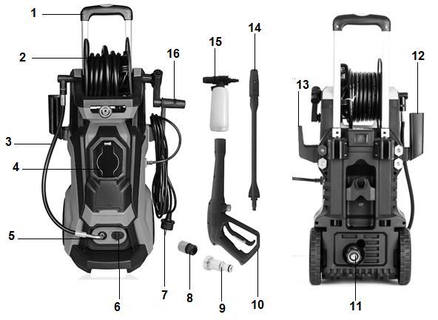

1. Handle
2. High pressure hose reel
3. High pressure hose
4. Screen display
5. Outlet connection
6. Unlock button
7. Power plug
8. Quick connector
9. Inlet filter
10. Gun
11. Inlet connector
12. Gun holder
13. Cable holder
14. Lance
15. Detergent bottle
16. Reel handle
17. **Technical data**

|  |  |
| --- | --- |
| Rated pressure | 10Mpa (100bar) |
| Permissible pressure (max.) | 15Mpa (150bar) |
| Power input | 2000W |
| Rated flow | 6.0L/min |
| Max. flow | 7.5L/min |
| Rated voltage | 230V~ |
| Rated frequency | 50Hz |
| Rated current | 8.7A |
| Degree of Protection | IPX5 |
| Protection class | II |
| Sound power level | 98 dB(A) |
| Sound pressure level | 80 ±3 dB(A) |
| Acceleration | 1.0±0.15 m/s2 |
| Water temperature Max. | 40℃ |
| N .W | 9.5 kg |
| The range of aluminum handle | 0-600mm |
| Inlet (max.) | 10bar |

1. **ASSEMBLY**

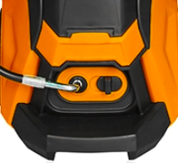**High pressure hose connection**

Connect the pressure hose to the machine’s outlet; make sure it is connected firmly. **See picture 1**

To disconnect the high pressure hose, push the knob on the ON position and then remove the hose.

**Outlet**

**Lance connection**

**Picture 1**

Connect the gun lance to the gun stock. Turn the gun lance counter clock wise until it locked in position. Connect the hose to the thread of gun. **See Picture 2**

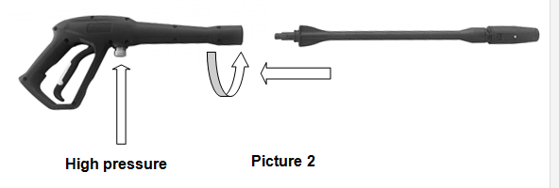

**Detergent bottle connection**

Connect the detergent bottle to the gun stock. Turn the detergent bottle counter clock wise until it locked in position. **See Picture 3**

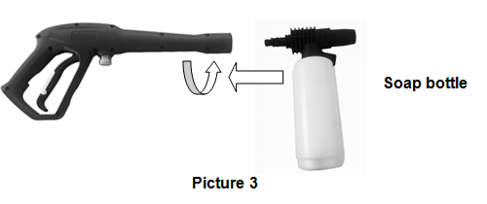

**Fill the detergent bottle**

* Unscrew the cap to open the bottle.
* Fill the bottle with detergent solution. Close the bottle with its cap.

When preparing the detergent solution, follow the instructions or recommendations of the manufacturer of the product used.

**Inlet hose connection**

* Screw the filter to the water inlet.
* Connect the quick connector to the filter. Connect then the water supply hose to the water inlet of the machine.
* The minimum recommended length for the water supply pipe is 10 meters (but not more than 25 meters) with a diameter of 12.5 mm to avoid back pressure and any potential damage to your appliance. Make sure it can withstand water and a maximum pressure of 10bar (0.1Mpa). If you want to connect your device to other water sources, make sure the maximum water inlet pressure is 10bar (0.1Mpa).
* Pull the trigger till all the air is pushed out of machine and water flows from the gun. It means now pump is full of water.

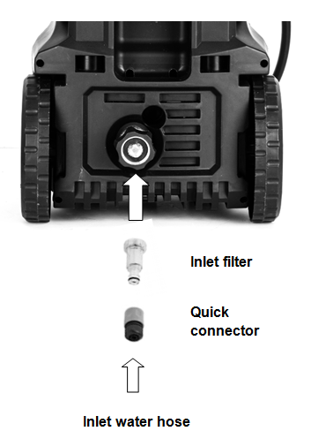

1. **USE**
2. **Electronic control center**

* Connecting water hose to inlet first, and turn on the tap. Make sure the machine is full of water. Then turn on the main switch.
* 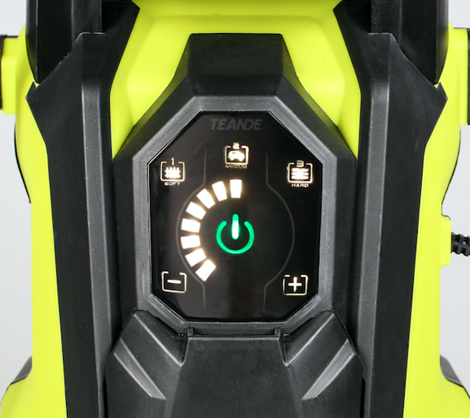Press the  in electronic control center to start the machine.
* The electronic control center has three pressure modes for users to choose. There is soft, medium and strong mode. The pressure depends upon which attachment is best suited to the surface you are cleaning.
* If you want to increase the pressure level, press the + button in the electronic control center.

**Picture 5**

* If you want to reduce the pressure level, press the - button in the electronic control center.
* When you increase the pressure level to make the pressure indicator turn red, it means that the machine is working at the maximum pressure. At this time, please do not let the machine work continuously for more than 15 minutes under the maximum pressure.
* Press  to switch off the machine.

1. **Use of detergents**

* This pressure washer is suitable for the use of universal cleaning agents for cars, for boats, for the house and the garden, recommended by the manufacturer and approved for use with high pressure cleaners.
* The use of other cleaning products or chemicals may impair the safety and functionality of the unit.
* When using cleaning agents, the dosing and application instructions of the cleaning product manufacturer must be observed.
* Do not use aggressive cleaning agents.
* Get advice on suitable cleaning products in specialized shops.

1. **Gun lance**

* By turning the tip of the nozzle which is on the lance, you can choose between the linear jet and the round jet for the projection.

1. **Cleaning operation**

* If necessary, start by cleaning the object in high pressure operating mode to remove most of the dirt.
* Spray the detergent on the surface to be cleaned and let it act for a few moments (do not let it dry!).
* Rinse at high pressure to remove the dirt that has been dissolved.

1. **MAINTENANCE AND STORAGE**
2. **Cleaning**

* Switch off the tool; unplug the power cord from the wall outlet.
* Turn off the water supply.
* Before disconnecting high-pressure hose connection, point the gun in a safe direction and discharge the high-pressure water.
* Disconnect high-pressure hose from the pressure cleaner and gun.
* Disconnect garden hose from the pressure cleaner.
* Unscrew the quick connector and filter. Clean them to remove debris and dirt.
* Remove excess water from the pump by tipping the unit on both sides to drain any remaining water from inlet and outlet fittings.
* Drain and clean de detergent reservoir.
* Wipe away any remaining water on all parts and fittings.
* Engage the gun safety lock.

1. **Maintenance**

* There is no specific maintenance to bring by end-user. In case of problem with the machine, contact our service client.
* Check all hoses and accessories for damage prior to use.

1. **Storage**

* Store the pressure cleaner, parts, and accessories in a safe place, out of reach of children. Do not store the machine in damp environment.

1. **TROUBLESHOOTING**

|  |  |  |
| --- | --- | --- |
| **Problem** | **Probable cause** | **Possible solution** |
| **The machine will not start working.** | 1. no power supply  2. faulty power supply.  3. locking ring of the pump too tight. | 1. contact the after-sales service |
| **No enough water coming out, uneven working pressure** | 1. the filter is blocked  2. inlet connection is not good, air in inlet pipe.  3. the valve is blocked  4. the outlet nozzle is not smooth. | 1. Clean the filter.  2. check the connection, tighten the seal. Check whether the hose is clogged or whether there is no enough inlet water.  3. clean the valve and install it again  4. contact the after-sales service |
| **Water leaking from the pump.** | 3 drops water every minute is permissible, but if more water leaked, may be the Sealing is worn out. | 1. contact the after-sales service |
| **The motor stops suddenly.** | 1. The pressure control worked.  2. The thermal protection may have switched the motor off to prevent overheating. | 1. Check if the outlet nozzle is blocked. Clean the nozzle  2. Turn off the cleaner, Leave the machine for a few minutes to cool down.  3. contact the after-sales service |

1. **DISPOSAL**

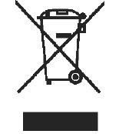

Electrical products should not be discarded with household products. According to the European Directive 2012/19/EU on waste electrical and electronic equipment and its implementation into national law, electrical products used must be collected separately and disposed of at collection points provided for this purpose. Talk with your local authorities or dealer for advice on recycling.

1. **WARRANTY**

We guarantee this product for 2 full years.

The warranty period for this item starts on the day of purchase. You can prove the date of purchase by sending us the original receipt.

We insure over the entire warranty period:

• Free repair of possible malfunctions.

• Free replacement of damaged parts.

• Including the free service of our specialized personnel (i.e. free assembly by our technicians)

Provided that the damage is not due to improper use of the device.

To help you with your product, we invite you to use this link or call us on +33 (0)9 70 75 30 30:

https://services.swap-europe.com/contact

You must create a "ticket" via their platform:

• Register or create your account

• Indicate the reference of the tool

• Choose the subject of your request

• Explain your problem

• Attach these files: Invoice or receipt, identification plate photo (serial number), photo of the part you need (egg broken transformer plug pins).



1. **DECLARATION OF CONFORMITY**



BUILDER SAS

ZI, 32 rue Aristide Bergès – 31270 Cugnaux - France

Declares that the machinery designated below:

HIGH-PRESSURE CLEANER

Ref.: FNHP2050CP

Serial number: 20200614369-20200614468

Complies with the provisions of the Directive “machinery” 2006/42/CE and national laws transposing it

Also complies with the following European directives:

EMC Directive 2014/30/EU

ROHS Directive 2011/65/EU

Directive on environmental noise emissions from equipment intended for use outside buildings 2000/14/EC

Guaranteed Sound Power Level: 98 dB(A)

Also complies with European standards, with national standards and the following technical provisions:

EN 60335-1:2012+A11:2014+A13:2017

EN60335-2-79:2012

EN 62233:2008

EN 55014-1:2017

EN 55014-2:2015

EN 61000-3-2:2014

EN 61000-3-3:2013

Cugnaux, on 19/05/2020

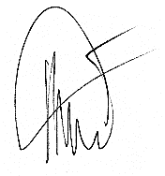

Philippe MARIE / PDG